**Australian Curriculum:  
Digital Technologies**

**Years 9–10**

**Sample assessment task**

**What do the data really reveal?**

**Assessment focus:** Australian Curriculum:Digital Technologies   
(Data)

**About this assessment task**

This sample assessment task has been prepared to assist teachers with the implementation of the Australian Curriculum: Digital Technologies, with a particular focus on *data*. It shows how aspects of the Digital Technologies curriculum related to data can be assessed using contexts from other learning areas and subjects. These contexts may be content that students have recently completed or are learning concurrently. This approach should enhance the manageability of the curriculum while still providing a targeted focus on Digital Technologies.

**Purpose**

The sample task aims to:

* demonstrate meaningful curriculum links to:
* Digital Technologies curriculum:
  + - achievement standard
    - content descriptions
    - content strands
    - key concepts
    - key ideas (Technologies)
* general capabilities
* cross-curriculum priorities
* other learning areas. See Appendix 1 for detailed links.
* provide teacher support materials, suggested adjustments for students with diverse needs and resources. See Appendix 2.
* provide a template to create your own assessment task. See Appendix 3.

**How to use this sample task**

The sample task can be implemented as a standalone task, or it can be used to inform planning   
of a:

* unit of work that might accompany the sample task
* similar task and/or unit of work with a focus on data.

# Title: What do the data really reveal?

**Assessment focus:** Australian Curriculum: Digital Technologies (Use digital tools to organise data, make sense of complex data and identify patterns and trends). This task is also linked to Science. Depending on modifications made, opportunities may exist to link this task to Mathematics and/or English.

**Band:** Years 9 and 10 (intended cohort Year 10)

**Context:** Processing and analysing data (useful in Science, Mathematics, Humanities and Social Sciences, Health and Physical Education and Digital Technologies)

**Duration:** About 10 hours

**Prior learning:** By the end of Year 8, students will have had the opportunity to:

* plan and manage digital projects to create interactive information
* define and decompose problems in terms of functional requirements and constraints
* evaluate information systems and their solutions in terms of meeting needs, innovation   
  and sustainability
* analyse and evaluate data from a range of sources to model and create solutions.

## Task summary

**Part 1 – Knowledge and skill development (the sample task)**

Students will participate in about 15 activities designed to provide necessary skills before they attempt the assessment task. Most of these activities are based on a large dataset related to koala admissions to an animal hospital in South East Queensland.

See Task features for an overview of the four sections that comprise Part 1.

**Part 2 – Understanding and skill application (the assessment)**

After completing the activities, students will identify a dataset of interest to investigate. The context may be research they need to do for another learning area/subject or an area of personal interest. The assessment task is informed by what students produce with their own investigation. They are assessed on the *application* of skills and understanding they covered in Part 1.

## Task features

To form accurate opinions about a topic, students will process and analyse data from a raw or modified (‘cleaned up’) dataset using spreadsheets, pivot tables, plotting data and, if the optional activity (Section 3) is undertaken, conduct scripting activities in Python.

Students will answer the following questions and learn the associated skills as they work through the activities and investigations in Part 1.

**Section 1**

What is the purpose of data? (suggested time allocation 2 hours)

* What is data?
* How can we collect data? (primary and secondary sources, and how to compare and evaluate)
* How can we use data to answer questions?
* What are the differences between qualitative and quantitative data?
* Correlation versus causation

**Section 2**

In what ways can software assist the management of large amounts of data? (suggested time allocation 3 hours)

* Explore sums, averages and other formulas in common spreadsheet packages
* Explore mapping data points onto maps with latitude and longitude
* Summarise data with pivot tables

**Section 3**

How can coding be used to interrogate large datasets? (suggested time allocation 3 hours)

* Explore large datasets with Python
  + ‘Cleaning up’ the dataset
  + Installing a Python integrated development environment (IDE)
  + Setting up the coding environment
  + Creating our first code to analyse a dataset
  + Making our visualisation easier to read
  + Making an alternative visualisation – bar chart
  + Using other data – working with dates
  + Making the charts easier to read and interpret

**Section 4**

What is the purpose of visualisation? (suggested time allocation 2–4 hours)

* What is visualisation? (Link to examples from other learning areas.)
* Evaluate data visualisations in terms of usefulness and whether they are misleading
* Explore Gapminder
* Use pivot charts to display analysed data

## Sample task background information

This sample task is designed to encourage students to interpret data in relation to koala deaths and is broken into four sections, which could be taught individually or in sequence depending on your situation.

In a teacher-modified version of this task, datasets other than the ones used in the sample task, investigating koala deaths, can be sourced from a variety of places. See Appendix 2 for suggestions. These suggestions could also be used as choices for the assessment task.

Figures 1 and 2 show examples of visual material that could be included to give students context for exercises related to data.

|  |  |
| --- | --- |
| A monkey sitting on a branch  Description automatically generated  Figure 1: image source https://tinyurl.com/y8lmnbnk | A close up of a map  Description automatically generated  Figure 2: image source https://tinyurl.com/yaurga2y |

## Part 1 – Knowledge and skill development (the sample task)

Following is a suggested series of lessons/activities that teachers can cover with their students. It begins with links to the Australian Curriculum, which are detailed in Appendix 1.

It also provides links to about 19 videos which explain the activities in some depth. These videos are primarily for teachers to gain an understanding if the concepts are new to them. They are also suitable for students to watch if needed.

At the end of Part 1, students should have enough knowledge and skills to attempt Part 2, which is the assessment task.

# Links to the Australian Curriculum

Table 1 shows the related Australian Curriculum links to this task. For a more in-depth exploration of the links to the curriculum, see Appendix 1.

Table 1: Links from the task to the Australian Curriculum: Digital Technologies 9–10

|  |  |  |  |
| --- | --- | --- | --- |
| **Digital Technologies**  ***Achievement standard***  Aspects addressed by this task are highlighted. | By the end of Year 10, students explain the control and management of networked digital systems and the security implications of the interaction between hardware, software and users. They explain simple data compression, and why content data are separated from presentation.  Students plan and manage digital projects using an iterative approach. They define and decompose complex problems in terms of functional and non-functional requirements. Students design and evaluate user experiences and algorithms. They design and implement modular programs, including an object-oriented program, using algorithms and data structures involving modular functions that reflect the relationships of real-world data and data entities. They take account of privacy and security requirements when selecting and validating data. Students test and predict results and implement digital solutions. They evaluate information systems and their solutions in terms of risk, sustainability and potential for innovation and enterprise. They share and collaborate online, establishing protocols for the use, transmission and maintenance of data and projects. | | |
| ***Content strands*** | Digital Technologies processes and production skills   * Collecting, managing and analysing data   Creating digital solutions by:   * Investigating and defining * Generating and designing * *Producing and implementing* * *Evaluating* | | |
| ***Content descriptions*** | * Develop techniques for acquiring, storing and validating quantitative and qualitative data from a range of sources, considering privacy and security requirements([ACTDIP036](http://www.scootle.edu.au/ec/search?accContentId=ACTDIP036)) * Analyse and visualise data to create information and address complex problems, and model processes, entities and their relationships using structured data[(ACTDIP037)](http://www.scootle.edu.au/ec/search?accContentId=ACTDIP037) * Define and decompose real-world problems precisely, taking into account functional and non-functional requirements and including interviewing stakeholders to identify needs ([ACTDIP038](http://www.scootle.edu.au/ec/search?accContentId=ACTDIP038)) * Design algorithms represented diagrammatically and in structured English …   [(ACTDIP040)](http://www.scootle.edu.au/ec/search?accContentId=ACTDIP040)  ***Optional – applicable only where coding is taught***   * *… validate algorithms and programs through tracing and test cases*[*(ACTDIP040)*](http://www.scootle.edu.au/ec/search?accContentId=ACTDIP040) * *Implement modular programs, applying selected algorithms and data structures including using an object-oriented programming language*[*(ACTDIP041)*](http://www.scootle.edu.au/ec/search?accContentId=ACTDIP041) * *Evaluate critically how student solutions and existing information systems and policies, take account of future risks and sustainability and provide opportunities for innovation and enterprise*[*(ACTDIP042)*](http://www.scootle.edu.au/ec/search?accContentId=ACTDIP042) | | |
| ***Key concepts*** | * data collection * data interpretation * algorithms * implementation * interactions | ***Key ideas*** | * Project management * Thinking in Technologies  – computational thinking |
| ***Cross-curriculum priorities*** | * Sustainability | ***General capabilities*** | * Information and Communication Technology (ICT) Capability * Literacy * Numeracy * Critical and Creative Thinking |

## Section 1 Working with large datasets (1 to 2 lessons)

What is the purpose of data? (suggested time allocation 2 hours)

* What is data?
* How can we collect data? (primary and secondary sources, and how to compare and evaluate)
* How can we use data to answer questions?
* What are the differences between qualitative and quantitative data?
* Correlation versus causation

**What is data?**

Students ideate to come up with a response. The teacher should direct them towards a definition that may include terms such as facts or presumed facts, statistics, used for reference, used for analysis.

What is the difference between data and information? Teacher could present the ‘1984’ example shown in Figure 3.

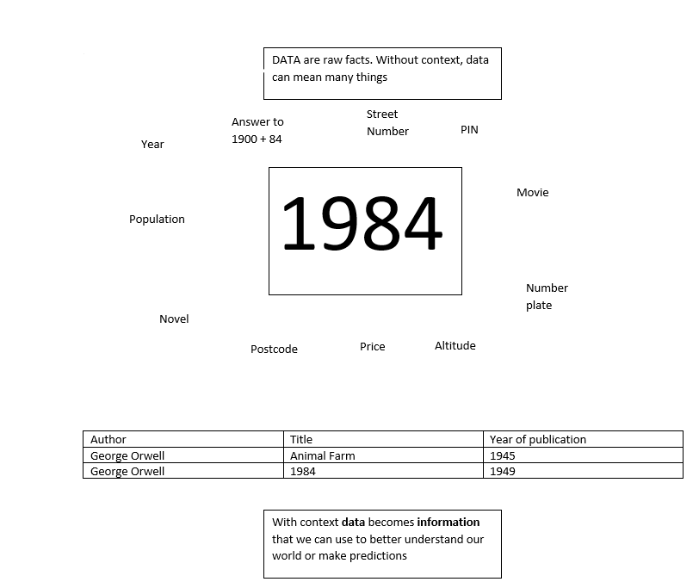

Figure 3: An example of the way the data ‘1984’ can mean many things depending on the context

**How can we collect data?**

Primary source data

Data coming from a source such as self or from firsthand experience are regarded as primary data. They need not necessarily be accurate.

**Activity:** Students graph their own typical daily routine – what time they get up, eat, travel, recreate, sleep, work, study etc. Use Excel to record data (could use a shared document).

Secondary source data

Published data or data collected in the past or from other parties is secondary data.

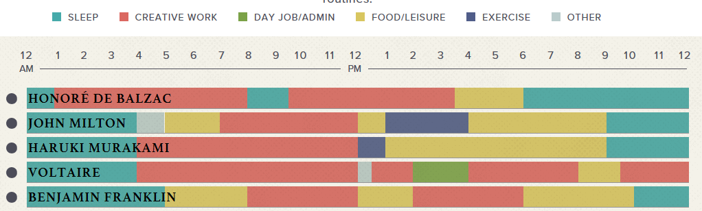**Activity:** Students go to <https://podio.com/site/creative-routines> (shown in Figure 4) to look at daily routines of some famous people.

Figure 4: The daily routines of famous creative people

**How can we use data to answer questions?**

The teacher leads students through data analysis questions. See below for modelled examples. Video tutorials for this activity: Student routines <https://youtu.be/RtFi_etNVjM> (11 minutes), Colour picker <https://youtu.be/hOLMYfQEx7s> (1 minute)

Looking at your own daily routine compared with the people in the list:

1. Are you likely to become a famous, creative person? Justify your conclusions.
2. What inferences can you make from the data?
3. What is the data telling you about work habits?

Make a class table* like the daily routines of famous, creative people.

1. What inferences can you make from the dataset?
2. What questions can we answer?

* Students should use a shared spreadsheet with an individual sheet within the file for each student (Figures 5 and 6) then linked together (Figure 7). Cut and paste seems the easiest way to do this where the only data is the fill colour.



Figure 5: Individual daily routine sheet for student Fred



Figure 6: Individual daily routine sheet for student Ling

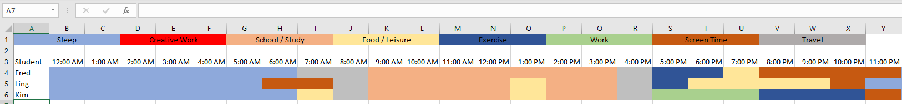

Figure 7: Combined spreadsheet for all students’ daily routines; cut and paste from individual sheets

**What are the differences between qualitative and quantitative data?**

Qualitative data is all about qualities something has – the squishiness of a cat, the colour of your eyes, what sort of day you had, the opinions of a group. You cannot really put a number to it – although researchers often try; for example: ‘Rate your day on a scale of 1 to 10’.

Quantitative data is all about measurement using numbers – the maximum temperature each day for a year, the weight of various cricket bats, the *number* of people in class who have blue eyes.

What sort of data have we collected on student routines in our previous example?

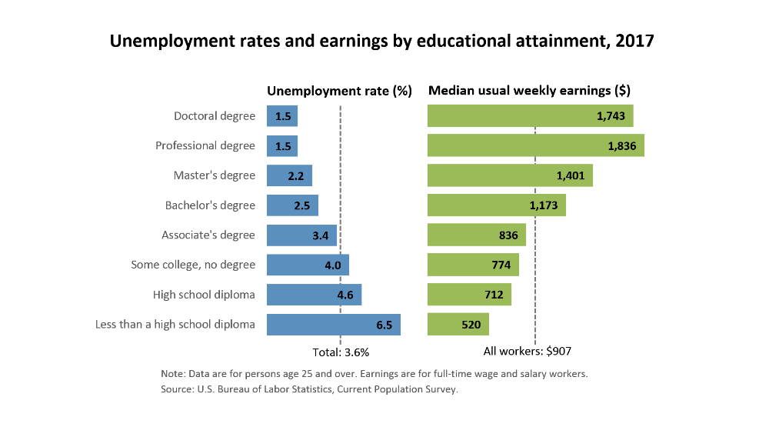**Correlation versus causation**

Show students the graph at Figure 8, which uses quantitative data. Have students respond to questions such as the following:

* What can you say about the amount you earn, the level of education and the unemployment rate?
* Can we say that the cause of higher unemployment is lower education levels (causation)?
* Or can we say that there appears to be a connection between education levels   
  and the level of unemployment?

Figure 8: An example of quantitative data that can be used for discussion with students  
Source: <https://www.bls.gov/emp/chart-unemployment-earnings-education.htm>

Next, have students look at these data relating to smoking and lung cancer (Figure 9).   
Again, ask them a question like this:

* Are we able to say that smoking causes lung cancer (causation) or only that there appears to be some sort of relationship (correlation)? Hindsight may make answering this more difficult than you think.

[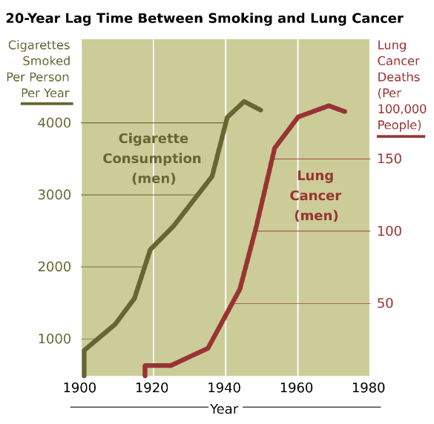](https://www.google.com.au/url?sa=i&rct=j&q=&esrc=s&source=images&cd=&cad=rja&uact=8&ved=2ahUKEwiAwtT_uMbgAhWFV30KHfLRBZYQjRx6BAgBEAU&url=https://commons.wikimedia.org/wiki/File:Cancer_smoking_lung_cancer_correlation_from_NIH.svg&psig=AOvVaw0xu7lLjEVh6jIrwt7KLo1_&ust=1550619249583671)

Figure 9: Cancer smoking lung cancer correlation   
Source: <https://commons.wikimedia.org/wiki/File:Cancer_smoking_lung_cancer_correlation_from_NIH.svg>

**Concluding activity**

Students can look at the following charts (Figures 10 and 11) to better understand correlation and how it is NOT causation.

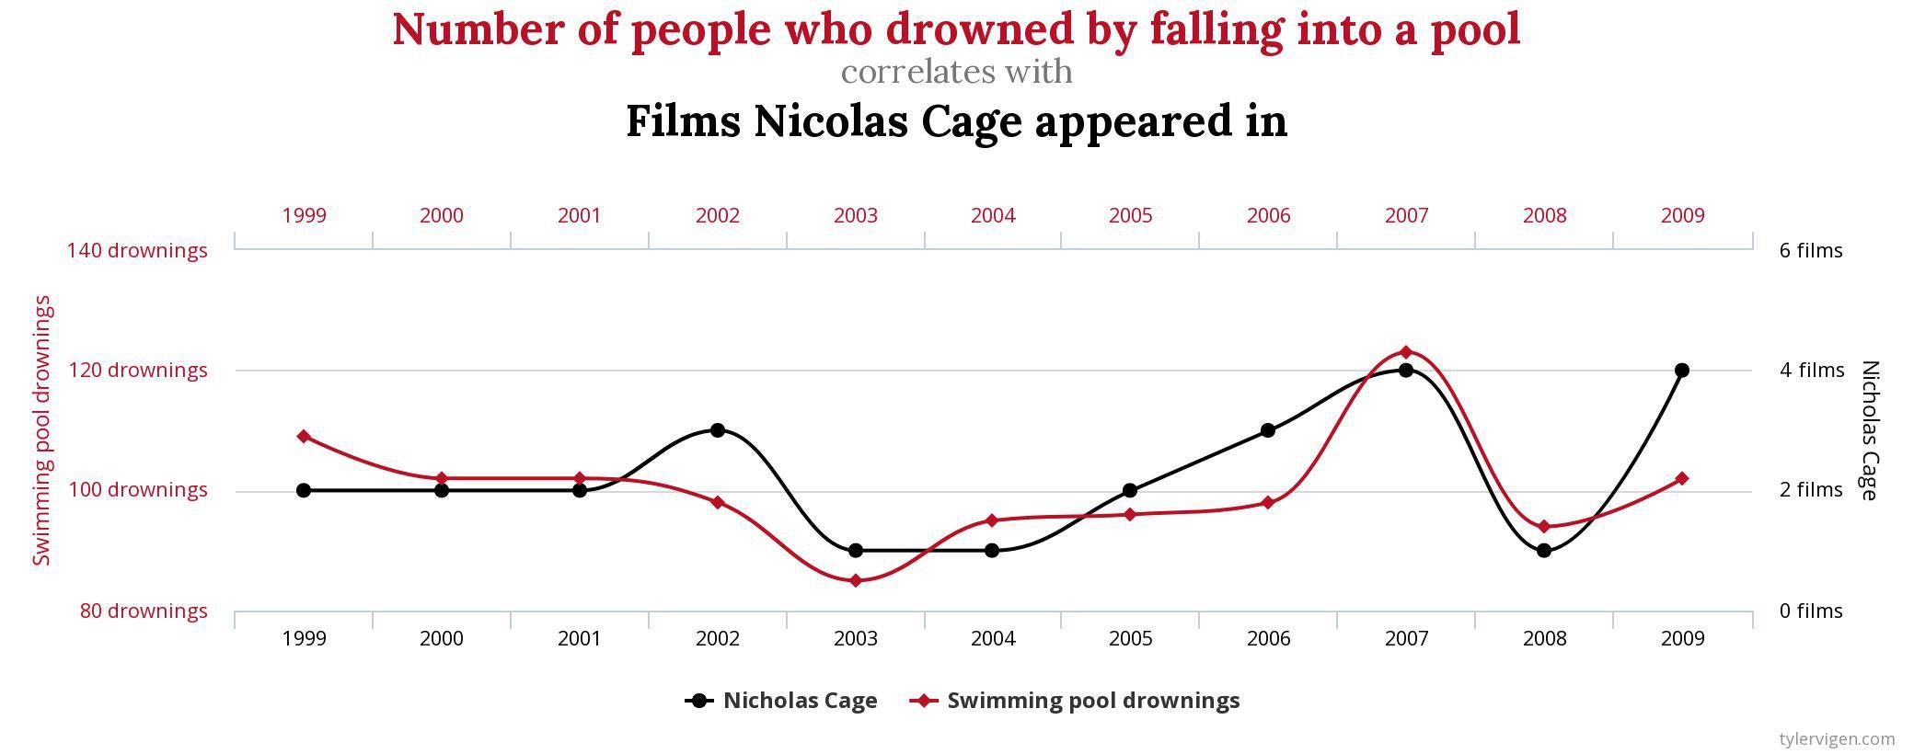

Figure 10: Example of a chart showing correlation but not causation

Source: [/www.reddit.com/r/SpuriousCorrelations/comments/828b5t/number_of_people_who_drowned_by_falling_into_a/](https://www.reddit.com/r/SpuriousCorrelations/comments/828b5t/number_of_people_who_drowned_by_falling_into_a/), accessed 6/7/2020

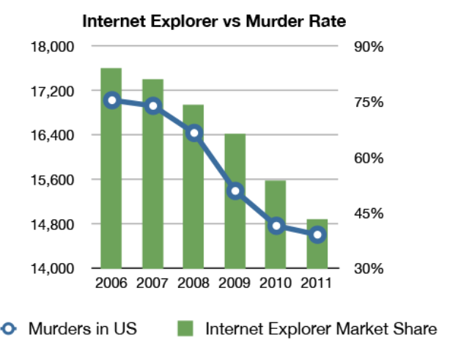

Figure 11: Example of a chart showing correlation but not causation

Source: www.reddit.com/r/SpuriousCorrelations, accessed 21/4/2020

## Section 2: Software tools for managing and analysing data (4–5 lessons)

In what ways can software assist the management of large amounts of data? (suggested time allocation 3 hours)

* Explore sums, averages and other formulas in common spreadsheet packages
* Explore mapping data points onto maps with latitude and longitude
* Summarise data with pivot tables

For this activity, teachers direct students to use the following koala hospital dataset:

<https://data.gov.au/dataset/ds-qld-9e3147cc-df40-4359-b603-845673401568/details?q=koala>

This is a large dataset – around 40,000 records held in 37 fields. Students will be using a mixture of ways to interrogate the data, starting with Excel spreadsheets. When you download the dataset save it as **koalabase2017** or rename it **koalabase2017** for ease of reference. Save it somewhere easy for the students to get access to.

Note: Excel online has a limitation of 5MB. If your school relies on the online version only of Excel, then this link <https://tinyurl.com/ybz7uftz> is to a smaller version of the file in .xlsx format. This format works for the Excel activities below but a comma-separated values (CSV) format is needed for the activities in the Python section.

Video link: Dataset introduction (3 minutes) <https://youtu.be/KVhwgqTlhbo>

**Explore sums, averages and other formulas in common spreadsheet packages**

*How many female koalas are admitted to hospital compared with males?*

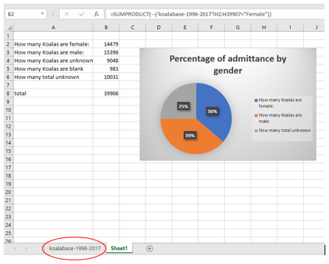

Figure 12: An example showing how a student might interrogate the koala hospital data using a spreadsheet

Teachers could get students to start with something like the example in Figure 12. Sheet1 is referencing the other sheet (koalabase-1996-2017) to keep data and interrogation separate. SUMPRODUCT is used to find the females. The double negative - - is used to turn Female into either a 0 or 1 so it can be counted.

Teachers need to point out to students that there are often many ways to provide solutions in spreadsheets. Have students complete the same calculation using the simpler COUNTIF function below and ask them which is better and why.

You could also use a simpler COUNTIF formula: =COUNTIF('koalabase-1996-2017'!H2:H39907,"Female")

Video links:

* Gender formula (7 minutes) <https://youtu.be/ADpLperF6IA>
* Gender chart (3 minutes) <https://youtu.be/gY0rzods8mo>

The COUNTIF function has been used in Figure 13 as well.

*How many koala injuries are from dog attacks compared with those hit by car?*

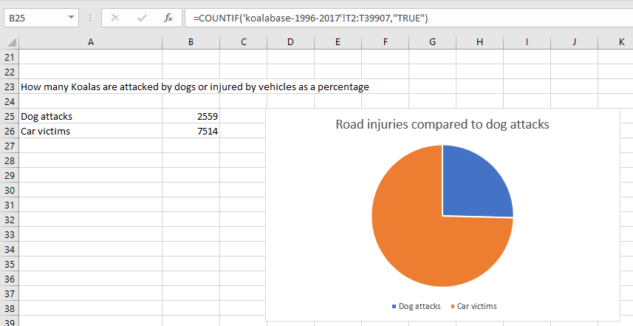

Figure 13: A spreadsheet showing the COUNTIF function

Video link: Dog vs Car (5 minutes) <https://youtu.be/08uHZ4NXy3Q>

*How many koalas are admitted to hospital per month?*

Figure 14 uses a SUMPRODUCT function as well as drilling into the date to find just the month details.

Teachers could have the students work out how to perform the same calculation with COUNTIF instead.

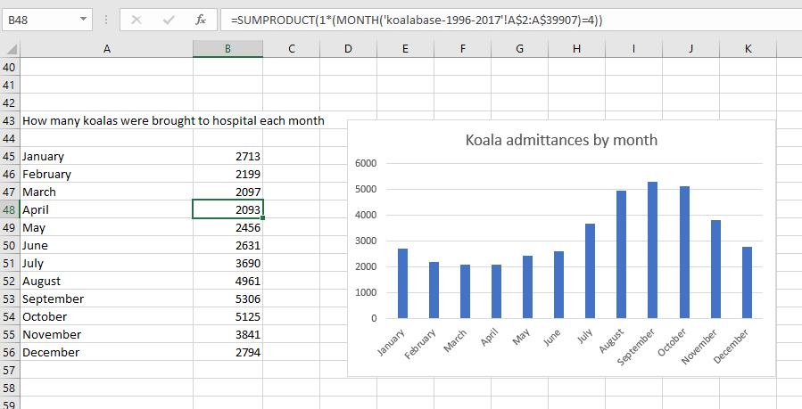

Figure 14: A spreadsheet showing the SUMPRODUCT function

Video link: Monthly admissions (12 minutes) <https://youtu.be/16hsUeygWnI>

From these data, students could see an obvious trend and research the reasons that spring is the most susceptible time for the animals.

There are numerous other questions that can be answered by analysing the data, such as:

* How prevalent is cystitis?
* How prevalent is conjunctivitis?
* Does road speed play a role in fatalities?
* What suburbs/postcodes are the most dangerous for koalas to live in?
* Where are most koalas released back to? Is this wise?

No doubt some of the formulas students could use may need to be researched. There is a myriad of online tutorials dealing with Excel formula writing.

**Explore mapping data points onto maps with latitude and longitude**

Note: The following activities require students to be able to use a Google login. In some jurisdictions such as NSW DET the student school login doubles as a Google login. In other jurisdictions teachers may need to come up with alternative login approaches. Class logins may be able to be assigned, for example.

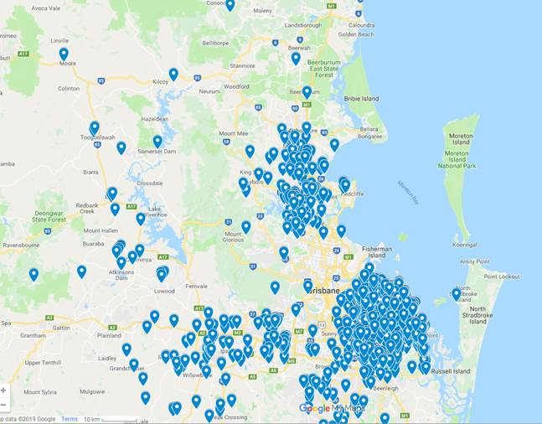

Figure 15: Koala place of death data plotted using Google MyMaps

*Source:* [*https://www.google.com.au/mymaps*](https://www.google.com.au/mymaps)

A worthwhile activity to do is to combine Google MyMaps and the latitude and longitude details given in the dataset.

The example in Figure 15 shows the data plotted using MyMaps, where you can create and share your own maps online.

Video link: Plotting data on MyMaps (8 minutes) <https://youtu.be/GAvkc5Lue6w>

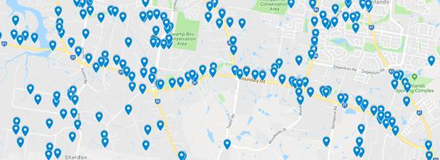The example in Figure 16 shows a zoomed-in view of a part of the data plotted in MyMaps. This allows you to see more closely what factors may be the cause of death.

Figure 16: Detail of data plotted in MyMaps

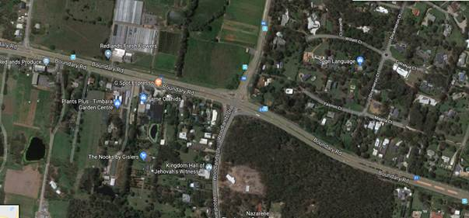The satellite image (Figure 17) is of part of the map at Figure 16. It highlights why the pattern of incidents is occurring.

Figure 17: Satellite image of part of the map at Figure 16

**Summarise data with pivot tables**

Following are a couple of examples of how pivot tables can be used to show the data in an easy to understand way. If you are not familiar with pivot tables there are many tutorials available online that may be useful, for example, <https://youtu.be/dIs9Tq6XwMw> (11.5 minutes).

The pivot table (Figure 18, left side) counts koala conjunctivitis rates by suburb. As there are about 380 suburbs listed (including blank suburb) the data are a little unwieldy.

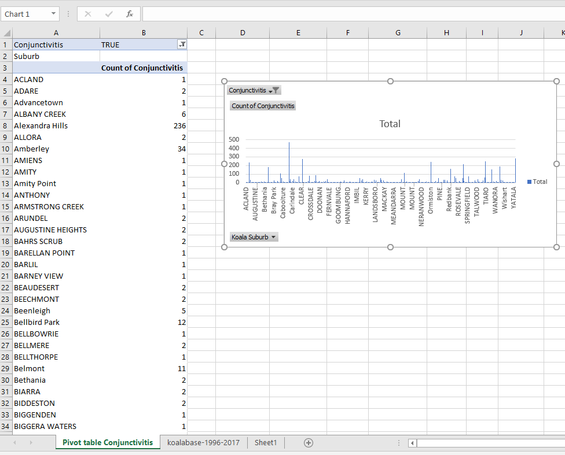

Figure 18: Pivot table and chart showing koala conjunctivitis rates by suburb

The pivot chart (Figure 18, right side) is a little better – it lists more suburbs as you expand the   
chart out.

These data could form the basis of a heat map which may indicate trends with the disease.

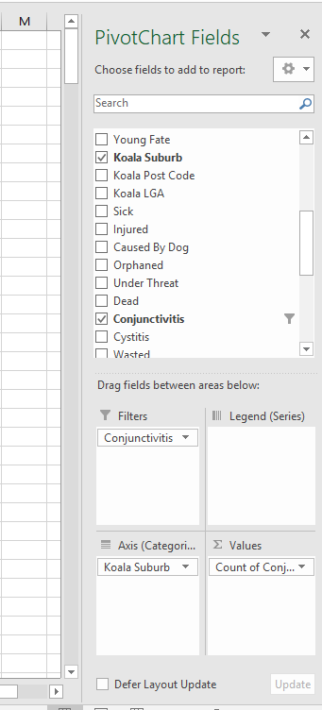The pivot chart field set-up for these data is shown in Figures 19 and 20.

Notice the filter for conjunctivitis is set to TRUE (Figure 20, cell B1). Without the filter, all 39,000+ cells are counted in the results.

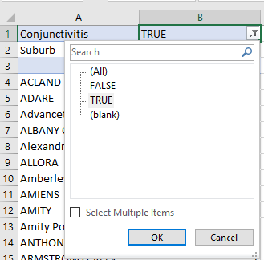

Figure 19: Pivot chart field set-up Figure 20: Pivot chart field set-up

Video link: Introduction to pivot tables and charts (5 minutes) <https://youtu.be/WbyQm6Tj8rc>

A better pivot chart may be conjunctivitis by postcode rather than suburb. That way, results for larger areas may be easier to work with.

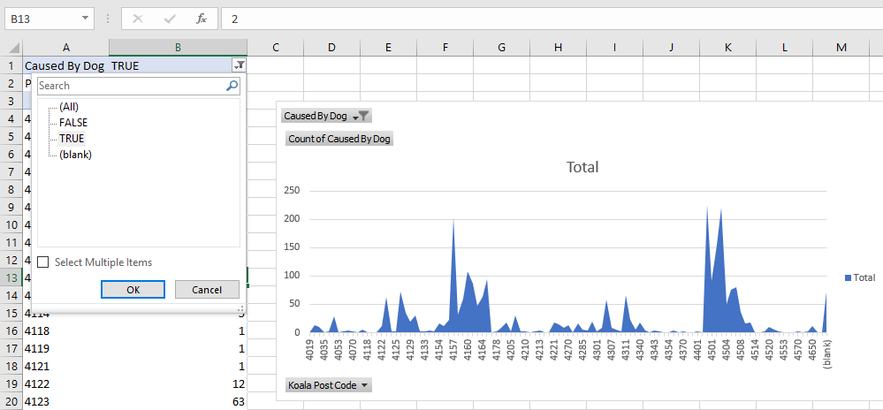The example in Figure 21 indicates koalas attacked by dogs by postcode. It would make an interesting map. There are about 108 postcodes. Normally postcodes with consecutive numbers like 4035 and 4036 are near each other. The area chart in Figure 21 represents these data well.

Figure 21: Data and chart showing koala deaths caused by dogs and the postcodes of deaths

Video link: More on pivot tables (7 minutes) <https://youtu.be/KNUsG6mT3Uw>

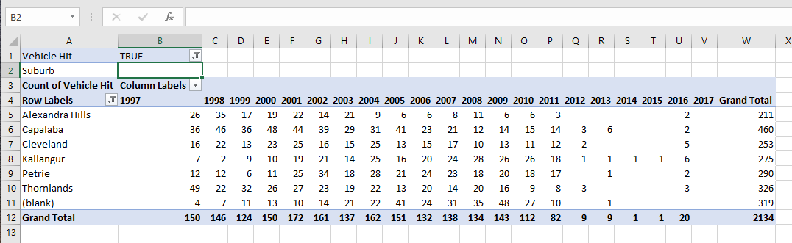Pivot tables can get quite complex. The final pivot table (Figure 22) lists the number of vehicle hits by suburb where the count is higher than 200. It also breaks down hits by year, so we should be able to see trends.

Figure 22: Koala deaths (where the count is higher than 200) by vehicle, area and year

The set-up for this more complex pivot chart (Figure 23) is relatively simple. With the data represented in this way we can see that there is a general trend for fewer injuries by vehicles over time.

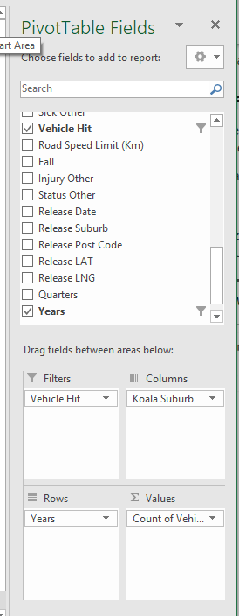Students should be encouraged to use these data to draw other conclusions. Also, they should be looking at satellite maps to draw conclusions as to why these are the locations with the highest rates of vehicle hits. Give them an opportunity to subsequently report back their findings and conclusions.

Figure 23: Identify trends with a pivot chart showing koala deaths by area and year

Video link: Pivot tables and charts final (5 minutes) <https://youtu.be/upka8LezqpI>

## Section 3: Using coding to explore large datasets (4–5 lessons)

How can coding be used to interrogate large datasets? (suggested time allocation 3 hours)

* Explore large datasets with Python
  + ‘Cleaning up’ the dataset
  + Installing a Python integrated development environment (IDE)
  + Setting up the coding environment
  + Creating our first code to analyse a dataset
  + Making our visualisation easier to read
  + Making an alternative visualisation – bar chart
  + Using other data – working with dates
  + Making the charts easier to read and interpret

**Note**: If your students have not worked much with Python or other general-purpose programming languages, you will need to do a reasonable amount of introductory work using Python before attempting the following activity.

**Explore large datasets with Python**

‘Cleaning up’ the dataset

The koala hospital dataset we have been working with contains some errors that need to be ‘cleaned up’ before we go on. Cleaning up datasets is a skill all data scientists need to develop.

The Python code activities that follow require the dataset to be cleaned up. This is because Python will detect an error for the field (column) it is trying to perform calculations on.

For example, a record such as ‘Koala half eaten, probably by dog’ results in an error because a comma in a CSV file is the delimiter, so it treats that cell as two separate values. There is a little more cleaning up to do – this could be a good exercise for students before they start working with their copy of the dataset.

Video link: Cleaning up a dataset (8 minutes) <https://youtu.be/G54mgWXjt2A>

**Considerations when accessing koala data**

A clean copy of the dataset can be found at: Koala database ‘cleaned up’ <https://tinyurl.com/ycg822db>. This file should be downloaded and distributed to students if they are not going to go through the clean up process themselves.

**Note:** ***The above link will not work in Excel online*** as the file size is greater than 5MB. Schools where students have accessed the dataset from an internal repository will not have this issue unless they then choose to use the Excel 365 online version of the software rather than the installed version.

***A solution is offered*** using this link <https://tinyurl.com/y7ktkye5> which reduces the file to an acceptable size for Excel online but which also obviously reduces the rich dataset.

***Alternatively***, the teacher could delete all but the first 10,000 rows, save it as CSV and look for clean-up issues with that much smaller dataset.

Installing a Python integrated development environment (IDE)

For the purposes of this activity, ***Spyder*** integrated development environment (IDE) has been chosen for its ease of use when working with large datasets in the Python language. It comes with the libraries we will be using already installed. There are two recommended ways to get it:

Use the WinPython installation <https://sourceforge.net/projects/winpython/> (link is the 3.7 version)

Use the Anaconda installation <https://www.anaconda.com/products/individual#download-section> (use the 3.7 version)

Video link: Installing the Python IDE (5 minutes) <https://youtu.be/_2Igu592Sng> – uses the *WinPython installation* as the example

Setting up the coding environment

Once you have successfully installed Spyder we can begin using Python to interrogate our dataset. The best thing to do is put the dataset and the code you are writing in the same folder. It doesn’t matter where – local, in the cloud or on a network – but when they are in the *same folder* then students can call the dataset by its name **‘koalabase2017’** rather than its full path ‘**c:\users\yourname\documents\Python\koalabase2017**’.

Video link: Setting up the coding folder (2 minutes) <https://youtu.be/FOmBVt9cVuM>

*You are encouraged to watch the videos (and even show them to the students) showing these activities as there are many step-by-step explanations which will help viewers understand what is happening. Just copying the code will not explain the computational thinking nor the Python syntax.*

Creating our first code to analyse a dataset

The first activity uses Python to:

* load necessary libraries
* read in the dataset – Python calls this a dataframe
* identify a column (field) where there are a manageable number of unique responses
* count the number of each unique response and store it in an array or series
* display each count as numbers
* display each count in a line chart.

Figure 24 shows what the code looks like.

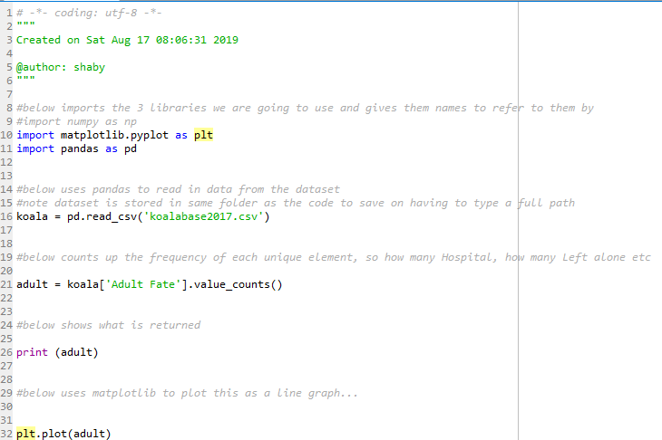

Figure 24: An example of the Python code that can be used to analyse a dataset

The results in the console are shown in Figure 25.

Video link: Creating a line chart (7 minutes) <https://youtu.be/PPrGIjizLCw>

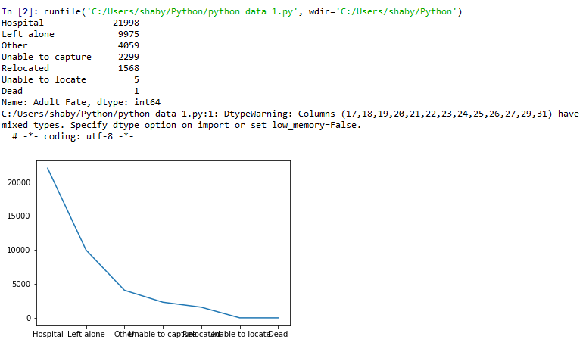

Figure 25: An example of a line chart

Making our visualisation easier to read

The second activity uses Python to do all the things in the first activity (Creating our first code to analyse a dataset) and make the line chart legible and useful as a visualisation.

Video link: Making the line chart easy to read (5 minutes) <https://youtu.be/DFPqmDFYDrw>

The code for this activity is shown at Figure 26 and the console output is shown at Figure 27.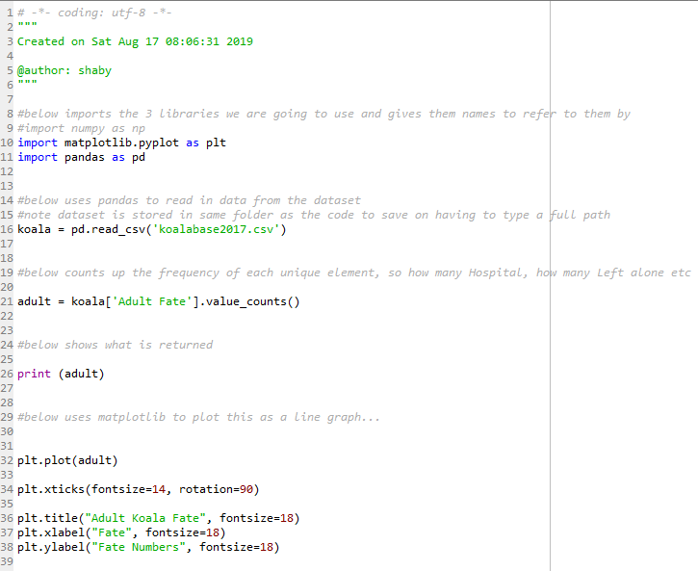

Figure 26: Code for the activity: Making our visualisation easier to read

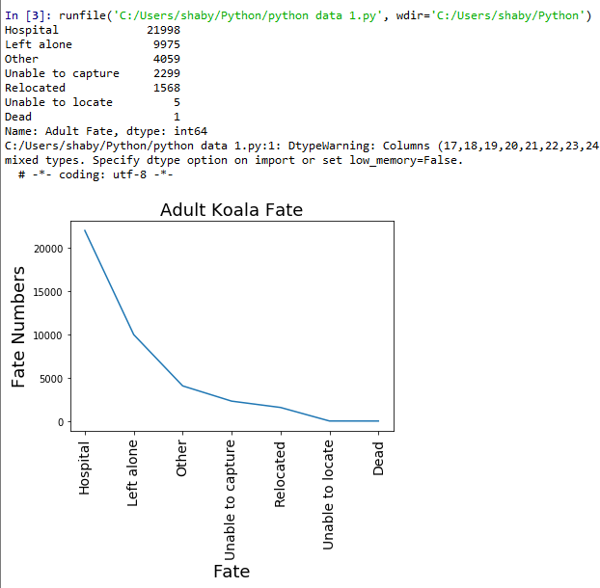

Figure 27: Console output for the activity: Making our visualisation easier to read – line chart

Making an alternative visualisation – bar chart

The third activity uses Python to:

* do all the things in the first two activities
* make a bar chart using the data
* improve legibility of the bar chart and make it useful as a visualisation.

Video link: Making the bar chart (5 minutes) <https://youtu.be/GM27DY9oA_8>

Figure 28 shows the code. Note: only lines from 44 on are new.

*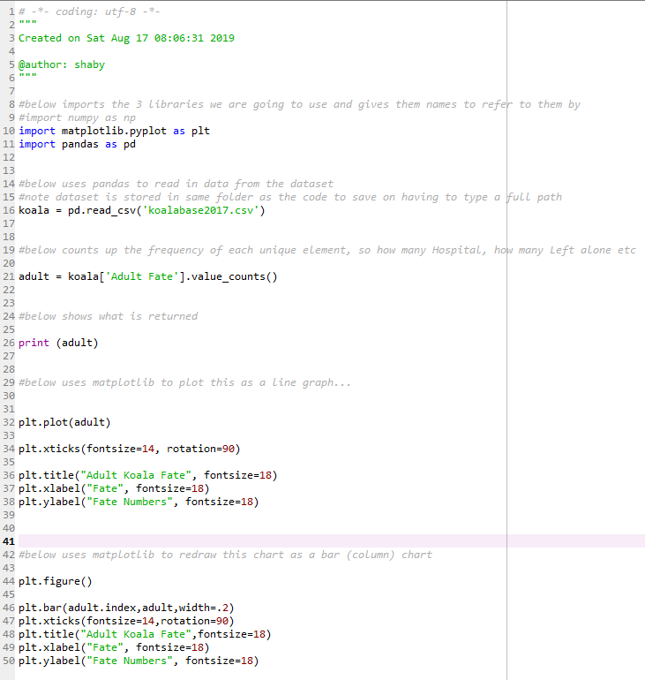**Figure 28: Code for the activity: Making an alternative visualisation – bar chart*

Figure 29 shows the console output for the activity as a bar chart.

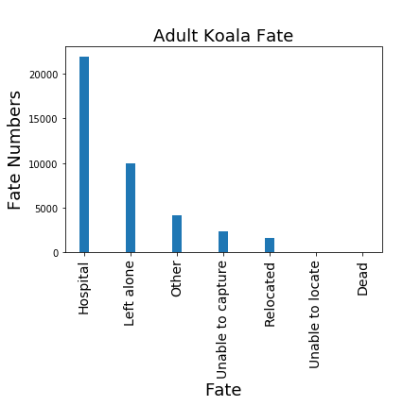

Figure 29: Console output for the activity: Making our visualisation easier to read – bar chart

Using other data – working with dates

The fourth activity uses Python to:

load necessary libraries

read in the dataset – Python calls this a dataframe

change the first column to an understandable date (so the days can be worked out)

create two lists or arrays:

* + - day (Sunday, Monday etc.)
    - count (how many times those days appear in the dataset)

print the arrays

plot the arrays as a line chart and a bar chart.

Figure 30 shows the code for this activity. For students in Years 9 and 10 to understand this there could be two lessons in just this code. It demonstrates just a fraction of what Python can do with data, but it may be enough to get students started.

Video link: Working with NumPy and dates (6 minutes) <https://youtu.be/hI0_BLdatvU>

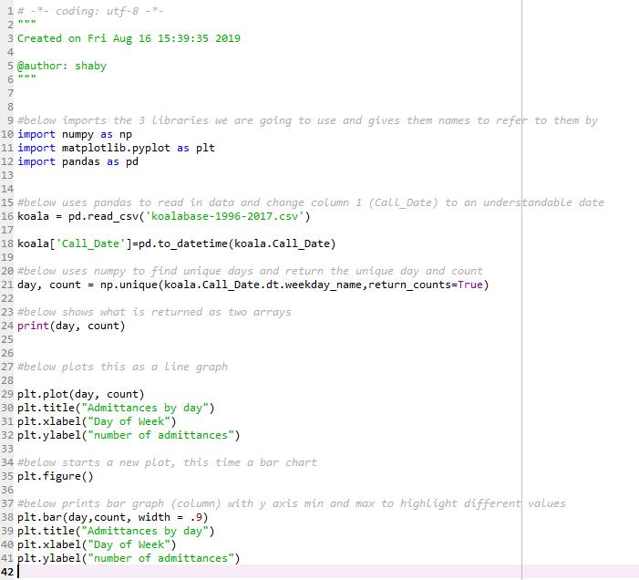

Figure 30: Code for the activity: Using other data – working with dates

When this code is run with the original dataset downloaded from the internet (‘koalabase-1996-2017’) an error occurs and Spyder gives only a hint as to what is wrong. The issue is not the code; it is that the dataset isn’t ‘clean’. Because humans populate the dataset, the data are open to all sorts of errors including missing data, spelling mistakes, and commas and wrong data types being inserted.

The fix for this error is very quick and easy to understand. It is addressed in the video, but the problem is that Python doesn’t like dates that are not there. In other words, there are missing data in the last record (row) and this throws up an error. Fix it by copying the date from one cell up into cell A39907 so a date exists.

*There are some other potential errors in data entry which could also affect the dataset. A final video called ‘Cleaning up the dataset’ takes students through locating other potential problems and fixing them. You could run this exercise with students just before they start interrogating their own chosen datasets.*

Figure 31 shows what the console output looks like when the code is run on a dataset that has had the final date inserted.

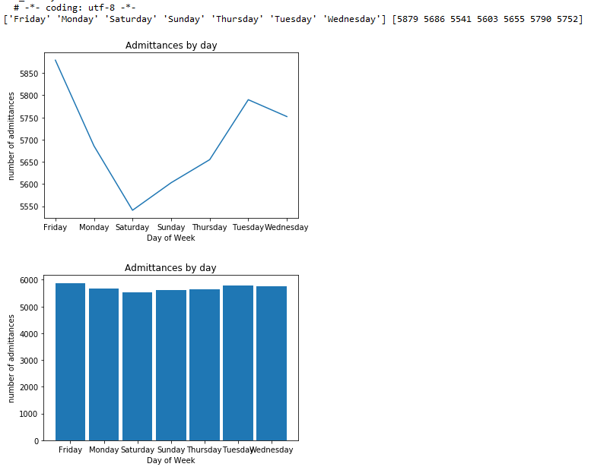

Figure 31: Console output for the activity: Using other data – working with dates

Making the charts easier to read and interpret

There are a couple of things that we can do to make our bar chart and line chart easier to read and interpret. One obvious problem is that the days of the week are not in a typical order, but rather ordered alphabetically. We would rarely want this.

The other way we can improve visualisation is to enhance the differences between the days in the bar chart. The differences are obvious in the line chart. See if you can work out why.

We will change the bar chart so it is able to show the differences more clearly.

The code to complete both these changes is at Figure 32 and the console output is at Figure 33. It is recommended you watch the video to gain an understanding of what is happening, especially if you are new to Python.

Video link: Making the chart easier to interpret and read (6 minutes) <https://youtu.be/ws4EFad8eYc>

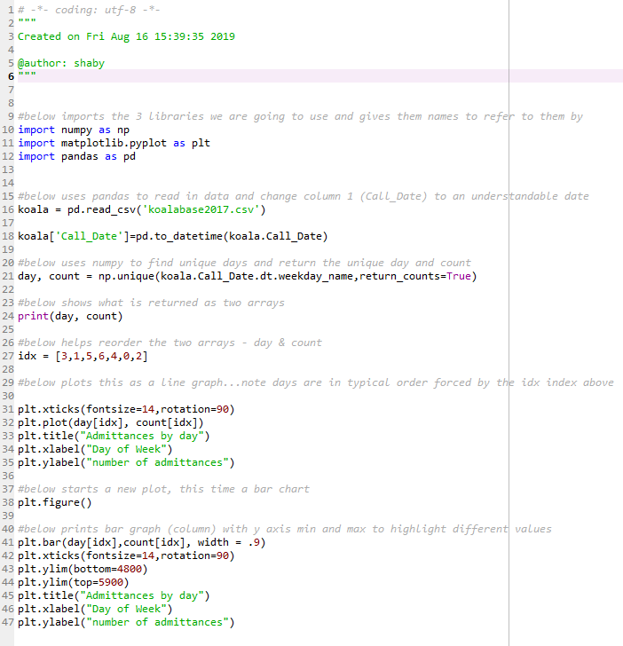

Figure 32: Code for the activity: Making the charts easier to read and interpret

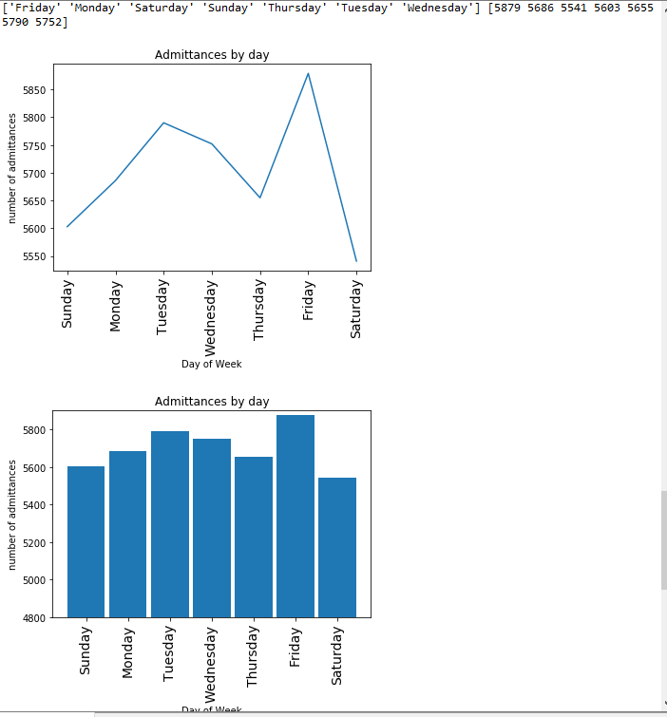

Figure 33: Console output for the activity: Making the charts easier to read and interpret

**Section 4: Visualisation (2–5 lessons*)**  
* depending on whether pivot charts were covered in Section 2

What is the purpose of visualisation? (suggested time allocation 4 hours)

* What is visualisation? (link to other learning areas)
* Evaluate data visualisations in terms of usefulness and whether they are misleading
* Explore Gapminder
* Use pivot charts to display analysed data

**What is visualisation? (link to other learning areas)**

See ‘An introduction to data visualisation’ at <https://tinyurl.com/y8sz8ka4>for an explanation of visualisation with plenty of examples and design pointers. The link above provides a copy of the document offered free at this site: <https://blog.hubspot.com/marketing/data-visualization-guide>

Students could work through parts of this document as a class activity. There are plenty of visualisations (many are US based) which link into various learning areas.

**Evaluate data visualisations in terms of usefulness and whether they are misleading**

See <http://tylervigen.com/page?page=1>

Students may have already done this activity on their own.

The link above demonstrates misleading data analysis and highlights that correlation does not mean causation.

Students could look for other examples such as Figure 34.



Figure 34: An example of a data visualisation that can be used to investigate correlation vs causation

**Explore Gapminder**

Gapminder allows students to explore data in various interesting ways. There are visualisations of data as well as pdf outlines explaining what to do in class with the students. An example is how global development has changed the world since 1800. <https://static.gapminder.org/GapminderMedia/GapPDFs/GapminderTeachersGuide200years/GapminderTeachersGuide200years.pdf>. See also the link to the related online interactive visualisation at <https://www.gapminder.org/tools/?from=world>

**Use pivot charts to display analysed data**

Again, this may have been done earlier in the koala mapping activity (see **Section 2, page 18**). If not, it could be done here, or a similar activity using a different dataset could be done here as reinforcement. The assessment task will require this so another treatment may be useful. Datasets that may be of use are listed at the end of this document.

**Part 2 –** **Assessment task**

After working through the learning activities, students should be ready to complete an assessment task based on what they have learnt and the skills they have developed. A key aspect of the assessment task should be delivery of findings in a suitable format. This activity would lend itself to students working in small groups.

Basically, the assessment task requires the students to apply their knowledge and skills with a totally new dataset. In **Appendix 2** there are about four datasets that would be suitable and which contain Australian content. There are many more available from all over the world which may also pique the students’ interests. It would be useful to restrict the students’ time on selecting a suitable dataset.

The datasets that are recommended that have an Australian flavour are:

* How can I use the road safely?
* Is my backyard snake free?
* How to succeed in life without really trying – Australian Taxation Office (ATO) and Census data
* What car should I buy?

Appendix 2 supplies links to these datasets as well as some questions to get students started. Links to other country’s datasets are also supplied. Students should not read the dataset headings above without the corresponding starter questions. The starter questions will give students a good idea of the sorts of analyses they can expect to undertake.

**Assessment planner and rubric**

Following you will find an assessment planner designed to give students a roadmap to successful completion of the assessment task. The planner also highlights many considerations that teachers could incorporate into the assessment if they wanted to make it more ‘project’ like. This would include having students complete a management plan, assess data validity and record predictions as outlined in the assessment planner.

A marking rubric is also supplied that could be used to help develop and grade the assessment task. This is designed to be simple and may need to be expanded to include aspects of the assessment planner the teacher is getting the students to complete.

**Assessment planner**

|  |  |
| --- | --- |
| **Achievement standard**  (relevant aspect of the achievement standard to be assessed) | **Student evidence**  (what student evidence will be considered to judge if the achievement standard aspect has been met) |
| **Digital Technologies** |  |
| Students explain why content data are separated from presentation | * Using the pivot tables and simpler formula work students explore the benefits of using cell references rather than the actual data in formulas (later change to data will be reflected accurately without the need for adjustment to the formula) * Using the Python visualisation exercises students experience the necessity to keep data out of code as much as possible in data analysis for readability, sustainability of the code as well as for abstraction and ease of updating of the data informing the visualisations. |
| Students plan and manage digital projects using an iterative approach. | * Plan an investigation of a large dataset working in a small group. Milestones could include: * Choose an appropriate area of investigation. * Locate and ‘clean up’ an appropriate dataset. * Make predictions of the types of findings that their investigation will reveal. * Interrogate chosen dataset using skills and knowledge gained over the unit including simple spreadsheet analysis, pivot tables and charts and data gleaned from Python (Pandas etc.) analysis. * Create visualisations which allow easy interpretation and understanding of the data. * Present findings of their investigation in an appropriate manner. |
| They take account of privacy and security requirements when selecting and validating data. | * Source datasets from trustworthy sites, where risk of raw data manipulation, misrepresentation and bias are unlikely. * Work with data in a secure environment ensuring that they do not falsify or leave data open to others falsifying or contaminating it in some way. |
| Students test and predict results and implement digital solutions. | * Scan fields and records to predict data analysis that may be interesting, controversial or unexpected (given the topic of the students’ own investigation). * Use digital solutions such as spreadsheets and/or coding analysis to produce visualisations of interesting data. * Draw conclusions from the data that they have worked with. * Compare initial predictions with the conclusions that the data have provided. (This should form part of their presentation). |
| They evaluate information systems and their solutions in terms of risk, sustainability and potential for innovation and enterprise. | * Reflect on the processes that they went through to create their final presentation; e.g. what did they like, what would they do differently, what couldn’t they do, what unexpected trends did the data uncover. * Determine interest groups such as government departments or businesses, based on the results of their investigation, with the view of disseminating the findings and conclusions they came up with and initiating contact with them. |

**Assessment rubric**

This rubric below shows only Digital Technologies.   
**Note:** There are opportunities to include Science, Literacy and Numeracy in the assessment. An assessment should be based on application of what the students have learnt. This example rubric describes the main activities undertaken in Part 1.

|  |  |  |  |  |
| --- | --- | --- | --- | --- |
|  | **Basic spreadsheet work** | **Plotting data** | **Pivot tables** | **Python scripting** |
| **Above Satisfactory** | Students provide a variety of charts and tables which demonstrate basic functions like sum, mean, median (or whatever is suitable) as well as more advanced tables which attempt to bring various data together to show correlations. | Students provide a variety of maps including heat maps, pin maps and satellite maps, based on all or part of the data.  They use maps to highlight and explain salient features of data. | Students provide pivot tables and charts which include a variety of data to interrogate the dataset in creative and innovative ways. | Students effectively use Python data libraries to provide visualisations on a variety of data which may explain correlations and probable causation. They interrogate data in innovative or interesting ways. |
| **Satisfactory** | Students provide a variety of charts and tables which demonstrate basic functions like sum, mean, median (or whatever is suitable). | Students provide some maps such as heat maps, pin maps or satellite maps, based on all or part of the data.  They use maps to highlight and explain some salient features of data. | Students provide basic pivot tables and charts which help describe the data. | Students provide a simple graph and table demonstrating some use of Python libraries such as Matplotlib, NumPy and Pandas. |
| **Below Satisfactory** | Students provide tables or charts which are difficult to interpret, and which only describe very basic analysis. | Students provide poorly executed/no maps such as heat maps, pin maps or satellite maps, based on all or part of the data.  They give little or no explanation of the data or its salient features. | Students provide a table or chart which may or may not be pivot and which provides little in the way of explaining or detailing the data. | Students supply coding which does not work. Data visualisations do not contain items such as explanations or labels. |

**Appendix 1  
Australian Curriculum links (in detail)**

**Links to the Australian Curriculum**

**Digital Technologies**

**Achievement standard**

By the end of Year 10, students explain the control and management of networked digital systems and the security implications of the interaction between hardware, software and users. They explain simple data compression, and why content data are separated from presentation.

Students plan and manage digital projects using an iterative approach. They define and decompose complex problems in terms of functional and non-functional requirements. Students design and evaluate user experiences and algorithms. They design and implement modular programs, including an object-oriented program, using algorithms and data structures involving modular functions that reflect the relationships of real-world data and data entities. They take account of privacy and security requirements when selecting and validating data. Students test and predict results and implement digital solutions. They evaluate information systems and their solutions in terms of risk, sustainability and potential for innovation and enterprise. They share and collaborate online, establishing protocols for the use, transmission and maintenance of data and projects.

**Content descriptions**

|  |
| --- |
| Develop techniques for acquiring, storing and validating quantitative and qualitative data from a range of sources, considering privacy and security requirements ([ACTDIP036](https://www.scootle.edu.au/ec/search?accContentId=ACTDIP036))  Analyse and visualise data to create information and address complex problems, and model processes, entities and their relationships using structured data ([ACTDIP037](http://www.scootle.edu.au/ec/search?accContentId=ACTDIP037))  Define and decompose real-world problems precisely, taking into account functional and non-functional requirements and including interviewing stakeholders to identify needs ([ACTDIP038](http://www.scootle.edu.au/ec/search?accContentId=ACTDIP038))  **Applicable where coding is taught:**  Design algorithms represented diagrammatically and in structured English and validate algorithms and programs through tracing and test cases ([ACTDIP040](http://www.scootle.edu.au/ec/search?accContentId=ACTDIP040))  Implement modular programs, applying selected algorithms and data structures including using an object-oriented programming language ([ACTDIP041](http://www.scootle.edu.au/ec/search?accContentId=ACTDIP041))  Evaluate critically how student solutions and existing information systems and policies, take account of future risks and sustainability and provide opportunities for innovation and enterprise ([ACTDIP042](http://www.scootle.edu.au/ec/search?accContentId=ACTDIP042)) |

Content strands

|  |  |  |  |
| --- | --- | --- | --- |
| **Digital Technologies knowledge and understanding** | | **Digital Technologies processes and production skills** | |
| Digital systems  Representation of data |  | Collecting, managing and analysing data  Creating digital solutions by:   * investigating and defining * generating and designing * producing and implementing * evaluating * collaborating and managing | X  X  X  X  X |

## Links to the key ideas

|  |  |  |
| --- | --- | --- |
| **Creating preferred futures** | Students develop solutions to meet needs considering impacts on liveability, economic prosperity and environmental sustainability. |  |
| **Project management** | Students will develop skills to manage projects to successful completion through planning, organising and monitoring timelines, activities and the use of resources. | X |
| **Thinking in Technologies**  – Systems thinking | Systems thinking is a holistic approach to the identification and solving of problems where the focal points are treated as components of a system, and their interactions and interrelationships are analysed individually to see how they influence the functioning of the entire system. |  |
| – Design thinking | Design thinking involves the use of strategies for understanding design needs and opportunities, visualising and generating creative and innovative ideas, planning, and analysing and evaluating those ideas that best meet the criteria for success. |  |
| – Computational thinking | Computational thinking is a problem-solving method that is applied to create solutions that can be implemented using digital technologies. It involves integrating strategies, such as organising data logically, breaking down problems into parts, interpreting patterns and models and designing and implementing algorithms. | X |

Read more about the [key ideas](https://www.australiancurriculum.edu.au/f-10-curriculum/technologies/key-ideas/) in the Australian Curriculum: Technologies.

### Links to the key concepts

The [key concepts](https://www.australiancurriculum.edu.au/f-10-curriculum/technologies/digital-technologies/structure/)that underpin the Digital Technologies curriculum establish a way of thinking about problems, opportunities and information systems and provide a framework for knowledge and practice. (Colour coding is based on the [Australian Computing Academy scheme](https://aca.edu.au/#what-is-the-digital-technologies-curriculum).)

|  |  |  |  |
| --- | --- | --- | --- |
|  | **abstraction** | underpins all content, particularly the content descriptions relating to the concepts of data representation, and specification, algorithms and implementation | |
|  | **data collection** | (properties, sources and collection of data) | X |
|  | **data representation** | (symbolism and separation) |  |
|  | **data interpretation** | (patterns and contexts) | X |
|  | **specification** | (descriptions and techniques) |  |
|  | **algorithms** | (following and describing) | X |
|  | **implementation** | (translating and programming) | X |
|  | **digital systems** | (hardware, software, and networks and the internet) |  |
|  | **interactions** | (people and digital systems, data and processes) | X |
|  | **impact** | (sustainability and empowerment) |  |

**Cross-curriculum priorities** [Read more …](https://www.australiancurriculum.edu.au/f-10-curriculum/cross-curriculum-priorities/)

|  |  |  |
| --- | --- | --- |
| **Aboriginal and Torres Strait Islander histories and cultures** | **Asia and Australia’s engagement with Asia** | **Sustainability** |
|  |  | X |

## General capabilities [Read more …](https://www.australiancurriculum.edu.au/f-10-curriculum/general-capabilities/)

|  |  |  |  |  |  |  |
| --- | --- | --- | --- | --- | --- | --- |
| **Literacy** | **Numeracy** | **ICT Capability** | **Critical and Creative Thinking** | **Ethical Understanding** | **Personal and Social Capability** | **Intercultural Understanding** |
| X | X | X | X |  |  |  |

### Links to ICT Capability continuum – Level 6 [Read more *…*](https://www.australiancurriculum.edu.au/f-10-curriculum/general-capabilities/information-and-communication-technology-ict-capability/) Depending on the year level this activity is being used with, please adjust content to appropriate level.

|  |  |
| --- | --- |
| **Applying social and ethical protocols and practices when using ICT** | |
| identify and describe ethical dilemmas and consciously apply practices that protect intellectual property |  |
| use a range of strategies for securing and protecting information, assess the risks associated with online environments and establish appropriate security strategies and codes of conduct |  |
| independently apply appropriate strategies to protect rights, identity, privacy and emotional safety of others when using ICT, and discriminate between protocols suitable for different communication tools when collaborating with local and global communities |  |
| assess the impact of ICT in the workplace and in society, and speculate on its role in the future and how they can influence its use |  |
| **Investigating with ICT** | |
| select and use a range of ICT independently and collaboratively, analyse information to frame questions and plan search strategies or data generation | X |
| use advanced search tools and techniques or simulations and digital models to locate or generate precise data and information that supports the development of new understandings | X |
| develop and use criteria systematically to evaluate the quality, suitability and credibility of located data or information and sources |  |
| **Creating with ICT** | |
| select and use ICT to articulate ideas and concepts, and plan the development of complex solutions | X |
| Design, modify and manage complex digital solutions, or multimodal creative outputs or data transformations for a range of audiences and purposes | X |
| **Communicating with ICT** | |
| select and use a range of ICT tools efficiently and safely to share and exchange information, and to collaboratively and purposefully construct knowledge | X |
| understand that computer mediated communications have advantages and disadvantages in supporting active participation in a community of practice and the management of collaboration on digital materials | X |
| **Managing and operating ICT** | |
| justify the selection of, and optimise the operation of, a selected range of devices and software functions to complete specific tasks, for different purposes and in different social contexts |  |
| apply an understanding of networked ICT system components to make changes to functions, processes, procedures and devices to fit the purpose of the solutions |  |
| manage and maintain data securely in a variety of storage mediums and formats |  |

**Links to Literacy**

In this Years 9–10 task in Digital Technologies, students have the opportunity to develop literacy by comprehending texts through listening, reading and viewing; composing texts through speaking, writing and creating; and using grammar, word and visual knowledge. They practise literacy skills as they listen to instructions and identify and respond to key information in spoken and multimodal texts, compose and edit learning area texts, and use language to interact with others. As students record observations, connect and express ideas, and make comparisons, they apply their knowledge of grammar and use subject-specific vocabulary. Students also use language to evaluate an object, action or text, and language that is designed to persuade the reader/viewer.

Visit Literacy general capability <https://www.australiancurriculum.edu.au/f-10-curriculum/general-capabilities/literacy/>

Visit National Literacy Learning Progression

<https://www.australiancurriculum.edu.au/resources/national-literacy-and-numeracy-learning-progressions/>

**Links to Numeracy**

In this Year 9–10 task in Digital Technologies, students have the opportunity to develop numeracy by identifying trends using number rules and relationships

In using software, materials, tools and equipment, students have opportunities to model, represent, order and use numbers in real-life situations. They gather, record and display data as tables, diagrams and graphs; explain findings; and recognise patterns. They compare, interpret and assess the effectiveness of different data displays of the same information.

## Visit Numeracy general capability <https://www.australiancurriculum.edu.au/f-10-curriculum/general-capabilities/numeracy/>

Visit National Numeracy Learning Progression

<https://www.australiancurriculum.edu.au/resources/national-literacy-and-numeracy-learning-progressions/>

**Links to other learning areas**

|  |
| --- |
| **Science** |
| **Year 10 Science achievement standard** (Aspects addressed by the task are highlighted.)  By the end of Year 10, students analyse how the periodic table organises elements and use it to make predictions about the properties of elements. They explain how chemical reactions are used to produce particular products and how different factors influence the rate of reactions. They explain the concept of energy conservation and represent energy transfer and transformation within systems. They apply relationships between force, mass and acceleration to predict changes in the motion of objects. Students describe and analyse interactions and cycles within and between Earth’s spheres. They evaluate the evidence for scientific theories that explain the origin of the universe and the diversity of life on Earth. They explain the processes that underpin heredity and evolution. Students analyse how the models and theories they use have developed over time and discuss the factors that prompted their review.  Students develop questions and hypotheses and independently design and improve appropriate methods of investigation, including field work and laboratory experimentation. They explain how they have considered reliability, safety, fairness and ethical actions in their methods and identify where digital technologies can be used to enhance the quality of data. When analysing data, selecting evidence and developing and justifying conclusions, they identify alternative explanations for findings and explain any sources of uncertainty. Students evaluate the validity and reliability of claims made in secondary sources with reference to currently held scientific views, the quality of the methodology and the evidence cited. They construct evidence-based arguments and select appropriate representations and text types to communicate science ideas for specific purposes.  **Content descriptions: Science Inquiry Skills** *Processing and analysing data and information*  Analyse patterns and trends in data, including describing relationships between variables and identifying inconsistencies [(ACSIS203)](http://www.scootle.edu.au/ec/search?accContentId=ACSIS203)  *Evaluating*  Evaluate conclusions, including identifying sources of uncertainty and possible alternative explanations, and describe specific ways to improve the quality of the data [(ACSIS205)](http://www.scootle.edu.au/ec/search?accContentId=ACSIS205)  Critically analyse the validity of information in primary and secondary sources, and evaluate the approaches used to solve problems [(ACSIS206)](http://www.scootle.edu.au/ec/search?accContentId=ACSIS206) |

**Appendix 2**

**Support materials**

## Things to think about

*Rich questions and discussion points*

Students with diverse needs

## Resources

## Support materials

## Things to think about

## *Rich questions and discussion points*

Teachers could have students consider/lead discussion on:

What effect does posted vehicle speed have on koala deaths?

What are the main causes of death?

Are koala injuries/deaths increasing or decreasing over time?

Can koala population data be found? If so where? How accurate are the data? How do   
you know?

What is happening to the rate of conjunctivitis?

What can be gained by examining data in a pivot table such as dog deaths vs non-dog deaths? (Consider using other data such as road deaths.)

## Students with diverse needs

Students who may need simplified, scaffolded support materials might benefit from adjustments such as:

making the dataset much smaller – that is, taking a subset of records as well as a subset of the fields provided

making the analysis (spreadsheet) consist of more general data techniques such as:

* + - finding mean, median, mode
    - counting up occurrences and graphing those

mapping using printed maps so students plot locations manually

using graphs that are hand drawn while still being based on the real data.

Students who need opportunities for extension might benefit from adjustments such as:

combining datasets together such as Australian Taxation Officer (ATO) and Australian Bureau pf Statistics (ABS) data and create data visualisations.

investigating other Python libraries apart from Pandas which can be used for data analysis.

working with datasets that are of particular interest to them and which may be more diverse than the examples given here.

## Resources

**Suggested datasets for the unit of work Sections 1–4:**

Koala Hospital Data (has CSV and over time)

<https://data.gov.au/dataset/ds-qld-9e3147cc-df40-4359-b603-845673401568/details?q=koala>

The dataset contains some errors which need to be ‘cleaned up’ before using them in Python. For example, the record ‘Koala half eaten, probably by dog’ results in an error because the comma in a CSV file is the delimiter, so that cell will be treated as two separate values. There is a little more cleaning up to do – this could be a good exercise for students; however, you can use [Koala database ‘cleaned up](https://1drv.ms/u/s!AuMO0Ohqk3nYg9l8xtoZe9YIJHnbag)’ if you don’t want to go through that process.

Koala Tracker (crowdsourced community research to save the koala) <http://www.koalatracker.com.au/>

## Alternative dataset links

The following datasets are from the Hackerspace website <https://hackerspace.govhack.org/data_sets>. There are many datasets (other than those listed) on the Hackerspace site, from water fountain locations to traffic camera offences, even all offences committed in New South Wales since 1995. Think about using a dataset that would interest Years 9 and 10 students. Many datasets are state specific, which also may be preferable. This list has been purposely limited to Australia; however, there are a large number of datasets available from all over the world, many from the USA and UK that students may want to explore. These are listed further below.

Note: Although there are many datasets to choose from, some ‘cleaning up’ will be necessary. As this is an introduction to datasets you may want to clean up the datasets yourself or have students do it if you want to assess that skill.

**How can I use the road safely? Australian Road Deaths Database**

**Dataset:** <https://data.gov.au/dataset/ds-dga-5b530fb8-526e-4fbf-b0f6-aa24e84e4277/distribution/dist-dga-fd646fdc-7788-4bea-a736-e4aeb0dd09a8/details?q=>

**Overarching question:** How safe are our roads?

**Sub-questions:**

What is the most dangerous day of the week to drive?

Is Christmas more dangerous than Easter?

Are fatalities reducing over time?

What are the most dangerous places to drive? (possible mapping exercise, e.g. heat map)

Should I ride a motorbike?

When is it safest to drive?

**Is my backyard snake free? Atlas of Living Australia**

**Dataset:** <https://downloads.ala.org.au/> (login required – access a number of datasets on different Australian living species on this site)

**Overarching question:** What kind of snakes live close to me?

**Sub-questions:**

What are the most common reptiles being sighted?

Where are the deadliest snakes found?

Are tiger snake numbers increasing?

When are death adders most active?

What reptiles are common around my area? (mapping exercise)

Where can I find the most geckos? (mapping exercise)

Note**:** This could be replicated for fish, insects, mosses, seed-bearing plants, molluscs (including oysters, octopuses, squid etc.), crustaceans (crabs, prawns, lobsters etc.) – all Australian data.

**How to succeed in life without really trying. Australian Government data.gov.au**

**Dataset:** <https://data.gov.au/dataset/ds-dga-ad383be7-4666-4bbb-bfd0-9fffb374beff/details>   
(<https://data.gov.au/> is a highly recommended site where all kinds of data can be found)

**Questions:**

Which postcodes have the most 0–4 year olds submitting tax returns?

Where do the oldest earning Australians live?

Which postcodes seem to be the richest?

Are richest postcodes correlated with the most charitable suburbs?

Which postcodes are most likely to attend university and are they more affluent postcodes?

Where do most people of the Americas live (maybe a mapping exercise based on postcode) and are they more likely to be single than people from Oceania?

Which postcodes are least likely to have private health insurance?

What other questions you could come up with that would extract more interesting data and correlations?

**What car should I buy? Australian Government data.gov.au**

This dataset provides data on vehicles that have had Register of Encumbered Vehicles (REVs) checks in 2017. Extra data was provided by the National Motor Vehicle Theft Reduction Council.

**Dataset:** <https://data.gov.au/dataset/ds-dga-6c637764-7cec-4d36-ac0b-5d84af3bb584/distribution/dist-dga-a1ab76b7-af74-4163-8fad-28ce4cade723/details?q=>

Students at this stage (Year 10) are usually very interested in vehicles and what they want to buy when they get their P plates. The data supplied in this database can be interrogated by them to answer a number of relevant questions:

What vehicle make is the most likely to be stolen?

What vehicle model is the most likely to be stolen?

Are older cars more likely to be stolen than newer vehicles?

Are car thefts declining as vehicles become more sophisticated?

What is the most popular style of vehicle (small, medium, large, SUV etc.)?

What colour car is least likely to be stolen if it is a Ford light commercial?

What vehicle is the most likely to be stolen per number registered?

## Other datasets and resources

**Digital Technologies Hub lesson ideas**

A Spreadsheet’s Secret Weapon: <https://www.digitaltechnologieshub.edu.au/teachers/lesson-ideas/a-spreadsheet-s-secret-weapon>

Everything You Always Wanted To Know: [https://www.digitaltechnologieshub.edu.au/teachers/lesson-ideas/everything-you-always-wanted-to-know](https://www.digitaltechnologieshub.edu.au/teachers/lesson-ideas/everything-you-always-wanted-to-know )

Seeing the Wood for the Trees: <https://www.digitaltechnologieshub.edu.au/teachers/lesson-ideas/seeing-the-wood-for-the-trees>

Seven Seasons (Indigenous seasons activities): <https://www.digitaltechnologieshub.edu.au/teachers/lesson-ideas/seven-seasons>

**Other datasets**

Aquifer salinity in SA over time (CSV):

<https://data.gov.au/dataset/ds-sa-4666f1a7-cde4-40d0-85ef-f7ec2aec7ca9/details?q=salinity>

Water quality data in the Murray-Darling Basin in NSW: <https://data.gov.au/dataset/ds-nsw-3f9c7bd3-8697-4777-ae7e-5aabbb6ff7c7/details?q=water%20quality>

Organisation for Economic Cooperation and Development – PISA scores (very useful, easy to navigate) <https://data.oecd.org/>

Europe statistics – population, immigration, wages, GDP etc. (Good visualisations)  
<https://ec.europa.eu/eurostat>

U.S. Bureau of Labor Statistics – job prospects, pay <https://www.bls.gov/>

Bureau of Justice Statistics (death penalty prisoners) – USA: <https://www.bjs.gov/latestreleases.cfm>

Sea turtle data as per <https://news.nationalgeographic.com/2018/01/australia-green-sea-turtles-turning-female-climate-change-raine-island-sex-temperature/>

**Appendix 3**

## Data task planning template

This template is a suggested step-by-step approach that teachers might use to consider whether *all* or *any* of these links apply to an assessment task they develop themselves to better reflect the learning needs of their students and the context of their classroom and school.

**Planning template suggested approach**

Below is a broad outline of how to use the assessment task planning template on the following pages. It reflects the work of Wiggins and McTighe (2012) on Understanding by Design, which features a backward design approach.

1. Begin with Digital Technologies:
2. determine the aspects of the achievement standard that will be the focus of the task
3. highlight the relevant aspects of the standard
4. identify what knowledge and skills students will need in order to demonstrate the achievement standards (content descriptions)
5. identify the strands and threads that will need to be addressed.
6. As Digital Technologies is the driving learning area, it is suggested that only the key ideas for this learning area be identified.
7. Indicate the key concepts of Digital Technologies that will be addressed and how.
8. Scan the Australian Curriculum to find meaningful connections between:
9. learning areas (two learning areas helps keep learning focused, avoid more than three)
10. general capabilities
11. cross-curriculum priorities.

For example, connections could be established on the grounds of:

1. common concepts/key ideas such as data/design/ways of thinking
2. common words, such as ‘create’, ‘communicate’ and ‘control’
3. contexts, from learning areas such as Science, HASS, HPE, The Arts.
4. Indicate what general capabilities and cross-curriculum priorities can be meaningfully addressed in the assessment task.
5. Construct a task that allows for discrimination in performance and includes:

* title
* band level
* duration
* task summary, including prior learning
* achievement standards and content descriptions
* task
* assessment rubric.

Replace xxxx with your own text.

**Title: xxxx**

**Assessment focus:** Australian Curriculum: Digital Technologies (Data). This task is also linked to xxxx. Depending on modifications made, opportunities may exist to link this task to other learning areas.

**Band:** Years 9 and 10 (intended cohort Year x)

**Context:** xxxx

***Duration:*** xxxx

**Prior learning:** Students will have:

* xxxx
* xxxx
* xxxx

## Task summary

Students will:

* xxxx
* xxxx
* xxxx

# Digital Technologies

**Digital Technologies**

**Achievement standard**

By the end of Year 10, students explain the control and management of networked digital systems and the security implications of the interaction between hardware, software and users. They explain simple data compression, and why content data are separated from presentation.

Students plan and manage digital projects using an iterative approach. They define and decompose complex problems in terms of functional and non-functional requirements. Students design and evaluate user experiences and algorithms. They design and implement modular programs, including an object-oriented program, using algorithms and data structures involving modular functions that reflect the relationships of real-world data and data entities. They take account of privacy and security requirements when selecting and validating data. Students test and predict results and implement digital solutions. They evaluate information systems and their solutions in terms of risk, sustainability and potential for innovation and enterprise. They share and collaborate online, establishing protocols for the use, transmission and maintenance of data and projects.

**Content descriptions**

|  |
| --- |
| Develop techniques for acquiring, storing and validating quantitative and qualitative data from a range of sources, considering privacy and security requirements[(ACTDIP036)](https://www.australiancurriculum.edu.au/Search/?q=ACTDIP036&t=ContentDescription)  Analyse and visualise data to create information and address complex problems, and model processes, entities and their relationships using structured data[(ACTDIP037)](http://www.scootle.edu.au/ec/search?accContentId=ACTDIP037)  Define and decompose real-world problems precisely, taking into account functional and non-functional requirements and including interviewing stakeholders to identify needs ([ACTDIP038](http://www.scootle.edu.au/ec/search?accContentId=ACTDIP038))  **Applicable where coding is taught**  Design algorithms represented diagrammatically and in structured English and validate algorithms and programs through tracing and test cases[(ACTDIP040)](http://www.scootle.edu.au/ec/search?accContentId=ACTDIP040)  Implement modular programs, applying selected algorithms and data structures including using an object-oriented programming language[(ACTDIP041)](http://www.scootle.edu.au/ec/search?accContentId=ACTDIP041)  Evaluate critically how student solutions and existing information systems and policies, take account of future risks and sustainability and provide opportunities for innovation and enterprise[(ACTDIP042)](http://www.scootle.edu.au/ec/search?accContentId=ACTDIP042) |

## Content strands [X any that apply]

|  |  |  |  |
| --- | --- | --- | --- |
| **Digital Technologies knowledge and understanding** | | **Digital Technologies processes and production skills** | |
| Digital systems  Representation of data |  | Collecting, managing and analysing data  Creating digital solutions by:   * investigating and defining * generating and designing * producing and implementing * evaluating * collaborating and managing |  |

## Links to the key ideas [X any that apply]

Read more about the [key ideas](https://www.australiancurriculum.edu.au/f-10-curriculum/technologies/key-ideas/) in the Australian Curriculum: Technologies.

|  |  |  |
| --- | --- | --- |
| **Creating preferred futures** | Students develop solutions to meet needs considering impacts on liveability, economic prosperity and environmental sustainability. |  |
| **Project management** | Students will develop skills to manage projects to successful completion through planning, organising and monitoring timelines, activities and the use of resources. |  |
| **Thinking in Technologies**   * Systems thinking | Systems thinking is a holistic approach to the identification and solving of problems where the focal points are treated as components of a system, and their interactions and interrelationships are analysed individually to see how they influence the functioning of the entire system. |  |
| * Design thinking | Design thinking involves the use of strategies for understanding design needs and opportunities, visualising and generating creative and innovative ideas, planning, and analysing and evaluating those ideas that best meet the criteria for success. |  |
| * Computational thinking | Computational thinking is a problem-solving method that is applied to create solutions that can be implemented using digital technologies. It involves integrating strategies, such as organising data logically, breaking down problems into parts, interpreting patterns and models and designing and implementing algorithms. |  |

**Links to the key concepts   
[X any that apply and insert ideas about how they could be addressed]**

The [key concepts](https://www.australiancurriculum.edu.au/f-10-curriculum/technologies/digital-technologies/structure/)that underpin the Digital Technologies curriculum establish a way of thinking about problems, opportunities and information systems and provide a framework for knowledge and practice. (Colour coding is based on the [Australian Computing Academy](https://aca.edu.au/#what-is-the-digital-technologies-curriculum) scheme.)

|  |  |  |  |
| --- | --- | --- | --- |
|  | **abstraction** | underpins all content, particularly the content descriptions relating to the concepts of data representation, and specification, algorithms and implementation | |
|  | **data collection** | (properties, sources and collection of data) |  |
|  | **data representation** | (symbolism and separation) |  |
|  | **data interpretation** | (patterns and contexts) |  |
|  | **specification** | (descriptions and techniques) |  |
|  | **algorithms** | (following and describing) |  |
|  | **implementation** | (translating and programming) |  |
|  | **digital systems** | (hardware, software, and networks and the internet) |  |
|  | **interactions** | (people and digital systems, data and processes) |  |
|  | **impact** | (sustainability and empowerment) |  |

## Cross-curriculum priorities [X any that apply] [Read more …](https://www.australiancurriculum.edu.au/f-10-curriculum/cross-curriculum-priorities/)

|  |  |  |
| --- | --- | --- |
| **Aboriginal and Torres Strait Islander histories and cultures** | **Asia and Australia’s engagement with Asia** | **Sustainability** |
|  |  |  |

## General capabilities [X any that apply] [Read more …](https://www.australiancurriculum.edu.au/f-10-curriculum/general-capabilities/)

|  |  |  |  |  |  |  |
| --- | --- | --- | --- | --- | --- | --- |
| **Literacy** | **Numeracy** | **ICT Capability** | **Critical and Creative Thinking** | **Ethical Understanding** | **Personal and Social Capability** | **Intercultural Understanding** |
|  |  |  |  |  |  |  |

## Links to ICT Capability continuum – Level [ ] [Read more … [X any that apply]](https://www.australiancurriculum.edu.au/f-10-curriculum/general-capabilities/information-and-communication-technology-ict-capability/)

### Depending on the year level this activity is being used with, please adjust content to appropriate level.

|  |  |
| --- | --- |
| **Applying social and ethical protocols and practices when using ICT** | |
| identify and describe ethical dilemmas and consciously apply practices that protect intellectual property |  |
| use a range of strategies for securing and protecting information, assess the risks associated with online environments and establish appropriate security strategies and codes of conduct |  |
| independently apply appropriate strategies to protect rights, identity, privacy and emotional safety of others when using ICT, and discriminate between protocols suitable for different communication tools when collaborating with local and global communities |  |
| assess the impact of ICT in the workplace and in society, and speculate on its role in the future and how they can influence its use |  |
| **Investigating with ICT** | |
| select and use a range of ICT independently and collaboratively, analyse information to frame questions and plan search strategies or data generation |  |
| use advanced search tools and techniques or simulations and digital models to locate or generate precise data and information that supports the development of new understandings |  |
| develop and use criteria systematically to evaluate the quality, suitability and credibility of located data or information and sources |  |
| **Creating with ICT** | |
| select and use ICT to articulate ideas and concepts, and plan the development of complex solutions |  |
| Design, modify and manage complex digital solutions, or multimodal creative outputs or data transformations for a range of audiences and purposes |  |
| **Communicating with ICT** | |
| select and use a range of ICT tools efficiently and safely to share and exchange information, and to collaboratively and purposefully construct knowledge |  |
| understand that computer mediated communications have advantages and disadvantages in supporting active participation in a community of practice and the management of collaboration on digital materials |  |
| **Managing and operating ICT** | |
| justify the selection of, and optimise the operation of, a selected range of devices and software functions to complete specific tasks, for different purposes and in different social contexts |  |
| apply an understanding of networked ICT system components to make changes to functions, processes, procedures and devices to fit the purpose of the solutions |  |
| manage and maintain data securely in a variety of storage mediums and formats |  |

**Links to Literacy and Numeracy**

Depending on the year level this activity is being used with, adjust content to appropriate level.

xxxx